AR-PIN: An Embedded Systems Learning Tool

Alan de Lima Silva, Etec da Zona Leste, [alan.silva397@etec.sp.gov.br](mailto:alan.silva397@etec.sp.gov.br)

Bruno Costa Rezende, Etec da Zona Leste, bruno.rezende01@etec.sp.gov.br

Edward Mevis da Silva, Etec da Zona Leste, edward.silva4@etec.sp.gov.br

Gustavo Dias da Silva Cruz, Etec da Zona Leste, gustavo.cruz90@etec.sp.gov.br

Jeferson Roberto de Lima, Etec da Zona Leste, jeferson.lima17@etec.sp.gov.br

**RESUMO.** *Com a crescente dependência da tecnologia e a necessidade de preparar os estudantes para o mundo digital, torna-se evidente a importância da disponibilização de recursos e utilização de ferramentas digitais. A falta de recursos eletrônicos para o aprendizado nas escolas é uma realidade enfrentada por muitas instituições de ensino no Brasil. Um dos recursos tecnológicos mais promissores para o aprendizado é o Arduino, um sistema embarcado que possuí uma plataforma de prototipagem eletrônica de código aberto que consiste em uma placa de circuito e um microcontrolador programável, contendo uma variedade de pinos de entrada e saída que permitem a conexão de diferentes componentes eletrônicos. O presente trabalho, portanto, foi elaborado a partir do citado problema, trazendo como resultado um aplicativo de realidade aumentada para explorar os conceitos de eletrônica, Arduino Uno R3 e sistemas embarcados. O aplicativo oferece recursos interativos, como, materiais didáticos, questionários e a possibilidade de visualização em tempo real de projetos com Arduino Uno R3 utilizando a realidade aumentada, permitindo que os estudantes aprendam de forma imersiva.*

**Palavras-chave.** Realidade. Aumentada. Arduino Uno R3. Sistemas Embarcados.

**Abstract.** With the growing dependence on technology and the need to prepare students for the digital world, the importance of providing resources and using digital tools becomes evident, the lack of electronic resources for learning in schools is a reality faced by many educational institutions in Brazil. One of the most promising technological resources for learning is Arduino, open-source electronics prototyping platform consisting of a circuit board and a programmable microcontroller, containing a variety of input and output pins that allow the connection of different electronic components. The present work, therefore, was elaborated from the mentioned problem, resulting in an augmented reality application to explore the concepts of electronics and Arduino Uno R3, the application offers interactive resources, such as didactic materials, questionnaires, and the possibility of real-time visualization of projects with Arduino Uno R3 using augmented reality, allowing students to learn in an immersive way.

**Keywords.** Augmented. Reality. Arduino Uno R3. Embedded Systems.

# 1. Introduction

**Following the proposal to improve the educational process, there is the possibility of using technological resources in pedagogical approaches, with the aim of stimulating learning. According to Christensen et al. (2013), when a new technology is introduced that complements the old, sustained innovation occurs, which has been historically positive.**

**The use of visual and tactile tools can be of great help for visual and kinesthetic learners. Resources such as concept maps, diagrams, videos, simulations, practical experiments, and physical replicas of abstract concepts can facilitate the learning of this type of student. According to Barbosa (2018), visual tools are representations that help to simplify and transmit ideas that can be modified. With regard to the assimilation of academic content, the educational institution must diversify the practices used in the classrooms to meet the diverse needs of students. For Saviani (1991), the school, as a representation of the educational institution, must also provide the tools necessary for the practice of science.**

**There is no doubt that information and communication technologies (ICTs), have caused a change in traditional teaching methods. Kenski (2007) attests that these technologies have brought considerable and positive changes to education. ICTs provide access to knowledge, making complex learning more accessible to students inside and outside the school environment. Computers have become a common tool in society, serving as a method for processing information in a variety of ways. Consequently, they are highly sought after as educational tools, since information is an integral part of learning (Valente et al, 1999). Education and computer science thus become allies with the objective of providing, training and sharing information and knowledge. With the proper introduction to this topic, its application becomes essential, and it is crucial that such tools be accessible to everyone. To validate and demonstrate the usefulness of this, this work follows an exploratory research with a bibliographic method, which, as demonstrated by Gil (1991), is carried out through the monitoring of books, articles, magazines, all demonstrations of other authors on the explained topic.**

# 2. Theorical Foundation

In this chapter, following the proposal based on exploring the theme, we provide the theoretical foundation, covering topics involved, first by the work theme, including the technologies and methods used to prepare and develop the project

1. Information and comunication tecnologies (ICT)

**Information and communication technologies (ICTs) have brought about major changes in current teaching methods, providing a more meaningful and interactive learning experience. Mattar (2010 cited in LOPES et.al., 2019) argues that ICTs can facilitate teaching and learning, allowing teachers to share knowledge in a dynamic way. Among the various ICTs, the technology that has stood out the most in academic use is augmented reality.**

**However, this advancement faces some barriers, such as the delay of educational institutions in adopting these technologies. Veen and Vrakking (2009 cited in LOPES et al., 2019) highlight that, despite technological advances, schools often cannot keep up with the technological fluency of students, disconnecting from the students' technological context. The use of information and communication technologies innovates and helps learning. Prensky (2012 cited in LOPES et al., 2019) emphasizes that due to the difference between the present day and the time when the school model was developed, the use of ICTs innovates and enhances the learning experience of today's students.**

1. Augmented Reality (RA)

**Augmented reality (AR) technology allows us to overlay the real world with virtual elements. Authors Tori, Kirner, and Siscouto (2006) define augmented reality as a virtual environment for interacting with the user's real world. The term Augmented Reality was coined in the United States by Tom Caudell and David Mizell. The proposal of AR is to complement the world around us with 3D objects. Ferreira (2014) argues that AR is constantly evolving, and that currently existing systems need to be adapted to the environment and the user.**

Figure 01 – Augmented Reality Example

Source: (From the author, 2023)

2.3 Electronic

**The field of science and engineering that studies how to control electrical energy through devices and conductive or semiconducting media is called electronics. According to the authors (BARBOSA; CANDIOTO, 2022), electronics uses electrical energy in low currents through devices that take advantage of the flow of electrons, allowing the creation of circuits with various applications.**

**Electrical voltage is measured in Volts (V) and represents the difference in electrical potential between two points. It is also responsible for the displacement of electrical charges. According to Miranda (2006), electrical voltage is the force capable of moving electrons in an orderly manner to and in a conductor.**

**Every material has an electrical resistivity, which is represented by ρ (density). Resistance is measured in Ohms (Ω). The authors (BARBOSA; CANDIOTO, 2022) highlight that Ohms are the ability of a body to hinder the passage of electrical current. To measure the differences in potential between the poles, we use the unit Ampere (A). For (BARBOSA; CANDIOTO, 2022), Amperes represent the orderly movement of electrical charges in a circuit.**

**Ohm's law establishes a relationship between electrical current, voltage difference, and resistance of a conductor, expressed by the formula:**

$I=\frac{V}{R}$ (1)

I = Current; V = Volts; R = Resistance

**The equivalent resistance is equal to the product of the sum of the respective resistors. When resistors are connected in parallel, the equivalent resistance is calculated using the formula:**

$\frac{1}{REQ}=\frac{1}{R1}+\frac{1}{R2}+\frac{1}{RN}$ (2)

Req = equivalent resistance; R1, R2, ..., Rn = individual resistors

Figure 02 – Electronic Example

Source: (From the author, 2023)

2.4 Arduino

**Arduino is a small computer that can be programmed to process inputs and outputs between the device and external components connected to it. According to Souza et al. (2011), Arduino is an open-source technology platform that uses light, sound, temperature sensors, and various output devices as inputs. The Arduino Uno differs from its predecessors by including a microcontroller that adapts a serial connection to USB. EVANS, Martin et al. (2013) highlight that by including a microcontroller, the Arduino Uno has a wide range of options for its use.**

Figure 03 – Example of Arduino

Source: (From the author, 2023)

2.5 Flutter

Developed and powered by Google, Flutter is an open source framework that makes use of the Dart programming language, also created by Google, according to (Venteu; Pinto, 2018), framework are sets of ready-made codes with already implemented functions for specific purposes. Flutter stands out for being hybrid and versatile, for Budiu (2013 apud (MARTINS *et al.*, 2020), hybrid applications become an ideal tool for reducing costs, due to the need to build the code only once.

# 3. Materials and Methods

For the development of this work, we used some materials, such as books, articles, and embedded systems.

Embedded systems are data processing devices designed to perform a specific function within a larger system effectively and reliably. Oliveira (2009) argues that embedded systems have come to take on tasks that were once manual, performing them successfully.

In this work, we used methods of documentary analysis and literature review, with extensive research and examination of all the information obtained. After understanding this data, the research will take on a qualitative approach, which will allow us to address and solve the problem in the best possible way.

The key elements of the methodology included bibliographic research, the fundamental concepts of Arduino, electrical and electronic principles, and the programming languages that would be used. This also involved the creation of structural and behavioral diagrams using the UML language, the construction of low- and high-fidelity wireframes to model the application's graphical interface, coding using the selected programming languages, and finally, the study of delivering the solution, which finalizes the development of the project, its documentation, and testing.

# 4. Results and Discussion

During the construction of this article, we noticed the significant impact of the lack of materials and components for learning about embedded systems on students and technology enthusiasts. This factor became even more evident during the COVID-19 pandemic, where a study by the Regional Center for Studies for the Development of the Information Society (Cetic), an entity linked to the Internet Steering Committee in Brazil (CGI), whose author of the research is (JANONE, 2021), reports that 93% of public schools faced a shortage of technology during the pandemic.

This situation emphasizes the urgent need to provide access to educational resources, especially in the area of electronics and embedded systems. In addition, it highlights the importance of technological innovation in education, highlighting how technology can fill gaps in learning and make knowledge more accessible, both inside and outside the school environment.

With the aim of demonstrating the importance of semi-face-to-face learning in education, the need for digital resources in education and the need to make these tools accessible to everyone, and the importance of stimulating learning through interactive tools, we hope to foster a discussion to take into account the pros and cons of these technologies.

# 4.1 AR-Pin: An Embbeded Systems learning tool

The AR-Pin app is a tool for learning and exploring the concepts of electronics, Arduino Uno R3, and embedded systems. The app offers interactive features, including educational materials, quizzes, and the ability to view the Arduino Uno R3 and some electronic components in real time using augmented reality, allowing students to learn in an immersive way. One of the project's goals is to make education accessible to everyone. With this in mind, we use a simple color palette with high contrast in our app so that it is easy to use the available content. We use the colors black, white, and red as the main colors. We also opted for a minimalist design with rounded edges combined with simple icons and lines to make the user experience more friendly and fluid. Below is the image of our application's home page:

Figure 04 - Home screen

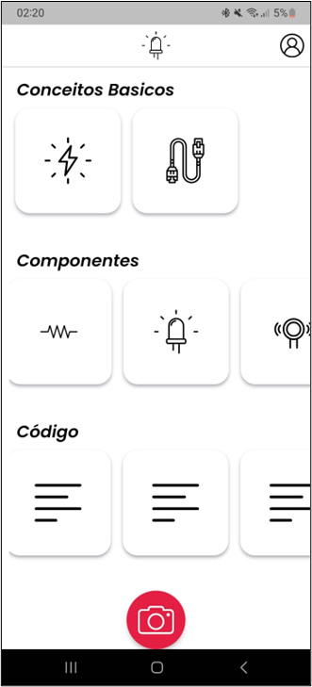

Source: (From the author, 2023)

In this image, we can see the home page of the AR-Pin application. It is divided into three categories where the contents of the application are displayed. The user can choose which tutorial they want to follow, from basic concepts for understanding Arduino to codes or its components.

Figure 05 - Tutorial screen

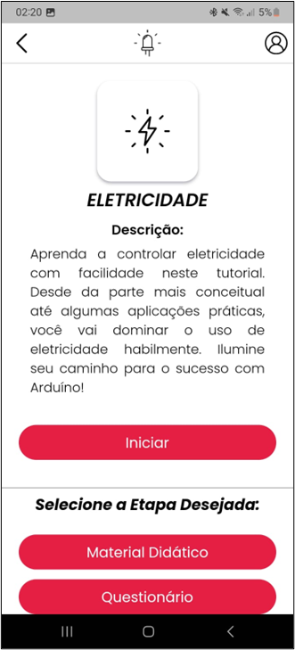

Source: (From the author, 2023)

The figure above shows the tutorial. The user receives a description of what will be covered in this tutorial and is given the option to select which steps they want to perform, choosing between completing all of them or not. The steps include reading the educational material and a questionnaire based on the content learned in the educational material.

Figure 06 - Teaching material screen

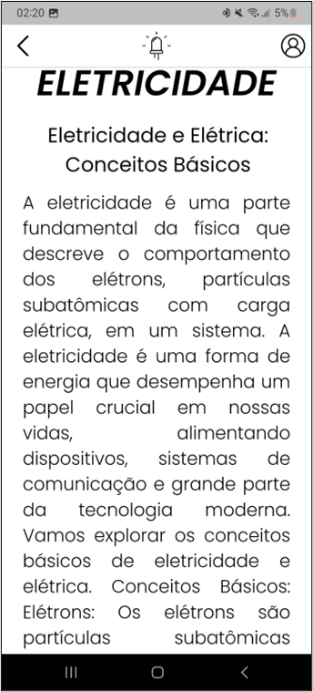

Source: (From the author, 2023)

The figure above shows the screen with the content of the educational material, where the theoretical content of the tutorial is explained.

Figure 07 - Quiz screen

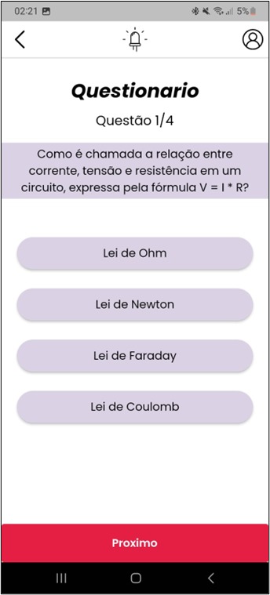

Source: (From the author, 2023)

The figure above shows the quiz screen, where the user can select only one answer among all. It is possible to retake the quiz if their performance is not satisfactory.

Figure 08 - Code example screen

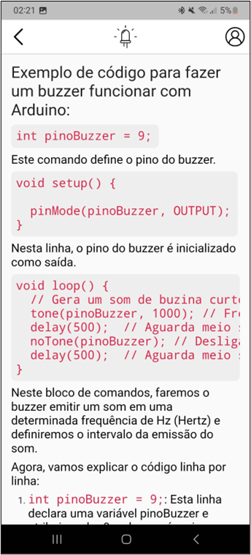

Source: (From the author, 2023)

The figure above shows an example of code for programming an Arduino project and its components. It presents the syntax of the code, what the code does, and explanations of the command lines, for a better understanding of the logical operation of the command.

# 5. Conclusion

**Blended education**, with a diversity of knowledge and tools that allow students to stimulate their learning through the scientific method, demonstrates innovation and better management of the talents of each individual, allowing them to develop a taste for learning according to their abilities.

The performance of a student depends on various causes and cannot be attributed only to motivation. As Pereira (2015) explains, the performance of a student depends on multiple variables of emotional, motivational, mental order, as well as other internal and external factors.

Educational institutions, among their many responsibilities, also have the task of providing tools for learning. According to Paulo Freire (1996), "teaching is not the transfer of knowledge, but the creation of possibilities for its own production or construction".

The objective of this work was to develop hypotheses, based on scientific rigor, for the creation of a system as a tool to provide accessible learning in the area of computational knowledge, specifically in embedded systems, using tools similar to those used in this project.

The hypothesis is that a learning system on embedded systems would contribute to the construction of knowledge in a way that is accessible to everyone. Its interactive and easy-to-use nature can serve as a stimulant for continuous learning and innovation, benefiting both individuals and society as a whole.

As developers and designers of this hypothesis to solve the challenging issue of the availability and accessibility of knowledge, together with hybrid education, we consider the tool as a satisfactory solution to the problem posed by the lack of electronic components for the learning of embedded systems students.

## Thanks

I would like to express my heartfelt gratitude to our supervisor, Jeferson Roberto de Lima, Professor Carlos, and the incredible team that worked diligently in the completion of our final project. Without the commitment and dedication of each one of you, this project would not have achieved the success it did.

Alan de Lima Silva, Bruno Costa Rezende, Edward Mevis da Silva, and Gustavo Dias da Silva Cruz, you were instrumental on this journey. Each of you brought unique skills and valuable contributions, making our work a true example of collaboration and collective effort.

# References

BARBOSA, Derick Mazelli; CANDIOTO, Katia Cristiane Gandolpho. **Prototipagem Eletrônica com Arduino**. Jundiaí: Edições Brasil, 2022. 64 p. Disponível em: https://www.researchgate.net/publication/363914529_PROTOTIPAGEM_ELETRONICA_COM_ARDUINO. Acesso em: 24 jul. 2023.

BARBOSA, Fabio José Marques et al. Visualização da Informação e Métodos Visuais como Ferramentas Estratégicas para o Gerenciamento de Projetos. **Revista de Gestão e Projetos**, [S.L.], v. 9, n. 1, p. 102-114, 3 maio 2018. University Nove de Julho. http://dx.doi.org/10.5585/gep.v9i1.635. Disponível em: https://periodicos.uninove.br/gep/article/view/9685/0. Acesso em: 09 jul. 2023.

CHRISTENSEN, Clayton M. *et al*. Ensino Híbrido: uma inovação disruptiva?. **Clayton Christensen Institute**: for Disruptive Innovation, Boston, v. 4, p. 1-43, 21 maio 2013. Traduzido para o Português por Fundação Lemann e Instituto Península. Disponível em: https://porvir.org/wp-content/uploads/2014/08/PT_Is-K-12-blended-learning-disruptive-Final.pdf. Acesso em: 25 jun. 2023.

EVANS, Martin *et al*. **Arduino Em Ação**. São Paulo: Novatec, 2013. 424 p.

FERREIRA, Joana Rita Santos. Realidade Aumentada: conceito, tecnologia e aplicações. 2014. 89 f. Dissertação (Mestrado) - Curso de Engenharia e Gestão Industrial, Universidade da Beira Interior, Covilhã, 2014. Disponível em: https://ubibliorum.ubi.pt/bitstream/10400.6/5907/1/3930_7645.pdf. Acesso em: 19 jul. 2023.

FREIRE, Paulo. Pedagogia da Autonomia. São Paulo: Paz e Terra, 1996.

GIL, Antonio Carlos. **Como Elaborar Projetos de Pesquisa**. 3. ed. São Paulo: Atlas S.A, 1991. 101 p. Disponível em: https://sgcd.fc.unesp.br/Home/helber-freitas/tcci/gil_como_elaborar_projetos_de_pesquisa_-anto.pdf. Acesso em: 26 jul. 2023.

JANONE, Lucas. **Pesquisa**: 93% das escolas públicas sofreram com falta de tecnologia na pandemia. 93% das escolas públicas sofreram com falta de tecnologia na pandemia. 2021. Disponível em: https://www.cnnbrasil.com.br/nacional/pesquisa-93-das-escolas-publicas-sofreram-com-falta-de-tecnologia-na-pandemia/. Acesso em: 03 jun. 2023.

KENSKI, Vani Moreira. **Educação e tecnologias**: o novo ritmo da informação. Campinas: Papirus, 2007. 144 p.

LOPES, Luana Monique Delgado; VIDOTTO, Kajiana Nuernberg Sartor; POZZEBON, Eliane; FERENHOF, Helio Aisenberg. **INOVAÇÕES EDUCACIONAIS COM O USO DA REALIDADE AUMENTADA: UMA REVISÃO SISTEMÁTICA**. **Scielo**, 2019 Disponível em: https://www.scielo.br/j/edur/a/D8BG7VqVDPmYk3d5xmCJJyF/. Acesso em: 21 jun. 2023

MARTINS, Alessandro Rocha *et al*. APLICATIVOS HÍBRIDOS: desenvolvimento de aplicativos utilizando tecnologias web. **Ambiente Acadêmico**, Cachoeiro de Itapemirim, v. 6, n. 1, p. 26-42, jan. 2020. Semestral. Disponível em: <https://multivix.edu.br/pesquisa-e-extensao/revista-cientifica-ambiente-academico/revista-ambiente-academico-volume-06-numero-01-2020/>. Acesso em: 27 jul. 2023.

MIRANDA JUNIOR, Luiz Carlos de. Segurança em instalações e serviços em eletricidade. São Paulo: Cpn, 2006. Disponível em: https://wiki.sj.ifsc.edu.br/images/0/04/NR10_Manual_Fundacentro.pdf. Acesso em: 01 jul. 2023.

OLIVEIRA, André de; ANDRADE, Fernando de. Sistemas Embarcados: Hardware e Firmware na Prática. 2. ed. Érica, 2009.

PEREIRA, Fernando Oliveira. Especificidades do rendimento, aptidão e motivação escolares em alunos com dificuldade de aprendizagem. 2015. Disponível em: https://www.scielo.br/j/pee/a/DkkYyDtKZ67dRNRVXK6YH7N/. Acesso em: 27 jun. 2023.

SAVIANI, Dermeval. Pedagogia Histórico-Crítica: primeiras aproximações. 2. ed. São Paulo: Cortez / Autores Associados, 1991. (Coleção polêmicas do nosso tempo; v. 5).

SOUZA, Anderson R. de; PAIXÃO, Alexsander C.; UZÊDA, Diego D.; DIAS, Marco A.; DUARTE, Sergio; AMORIM, Helio S. de. A placa Arduino: uma opção de baixo custo para experiências de física assistidas pelo pc. Revista Brasileira de Ensino de Física, [S.L.], v. 33, n. 1, p. 01-05, mar. 2011. FapUNIFESP (SciELO). <http://dx.doi.org/10.1590/s1806-11172011000100026>. Acesso em: 25 jul. 2023.

TORI, Romero; KIRNER, Claudio; SISCOUTTO, Robson. **Fundamentos e Tecnologia de Realidade Virtual e Aumentada**. Belém Pa: Editora Sbc – Sociedade Brasileira de Computação, Porto Alegre, 2006. 422 p. Disponível em: https://pcs.usp.br/interlab/wp-content/uploads/sites/21/2018/01/Fundamentos_e_Tecnologia_de_Realidade_Virtual_e_Aumentada-v22-11-06.pdf. Acesso em: 23 jun. 2023.

VALENTE, José Armando; FREIRE, Fernanda Maria Pereira; ROCHA, Heloísa Vieira da; D'ABREU, Jose Vilhete; BARANAUSKAS, Maria Cecília Calani; MARTINS, Maria Cecília; PRADO, Maria Elisabete Brisola Brito (org.). O computador na sociedade do conhecimento. Campinas: Nied, 1999. 116 p. Disponível em: http://penta3.ufrgs.br/MEC-CicloAvan/integracao_midias/textos/1pref.pdf. Acesso em: 06 jun. 2023.

VENTEU, Kelly Cristina; PINTO, Giuliano Scombatti. DESENVOLVIMENTO MÓVEL HÍBRIDO. **Revista Interface Tecnológica**, [S.L.], v. 15, n. 1, p. 86-96, 30 jun. 2018. Interface Tecnologica. <http://dx.doi.org/10.31510/infa.v15i1.337>. Acesso em: 20 jul. 2023.